**Chapter – 1**

1. **INTRODUCTION**
   1. **BRAIN TUMOR DETECTION SYSTEM**

The human body is made up of many organs and brain is the most critical and vital organ of them all. One of the common reasons for dysfunction of brain is brain tumor. A tumor is nothing but excess cells growing in an uncontrolled manner. Brain tumor cells grow in a way that they eventually take up all the nutrients meant for the healthy cells and tissues, which results in brain failure. Currently, doctors locate the position and the area of brain tumor by looking at the MR Images of the brain of the patient manually. This results in inaccurate detection of the tumor and is considered very time consuming. A Brain Cancer is very critical disease which causes deaths of many individuals. The brain tumor detection and classification system is available so that it can be diagnosed at early stages. Cancer classification is the most challenging tasks in clinical diagnosis.

This project deals with such a system, which uses computer, based procedures to detect tumor blocks and classify the type of tumor using Convolution Neural Network Algorithm for MRI images of different patients.

Different types of image processing techniques like image segmentation, image enhancement and feature extraction are used for the brain tumor detection in the MRI images of the cancer-affected patients.

Detecting Brain tumor using Image Processing techniques its involves the four stages is Image Pre-Processing, Image segmentation, Feature Extraction, and Classification. Image processing and neural network techniques are used for improve the performance of detecting and classifying brain tumor in MRI images.

**OVERVIEW OF BRAIN AND BRAIN TUMOR**

Main part in human nervous system is human brain. It is located in human head and it is covered by the skull. The function of human brain is to control all the parts of human body. It is one kind of organ that allows human to accept and endure all type of environmental condition. The human brain enables humans to do the action and share the thoughts and feeling. In this section we describe the structure of the brain for understanding the basic things.

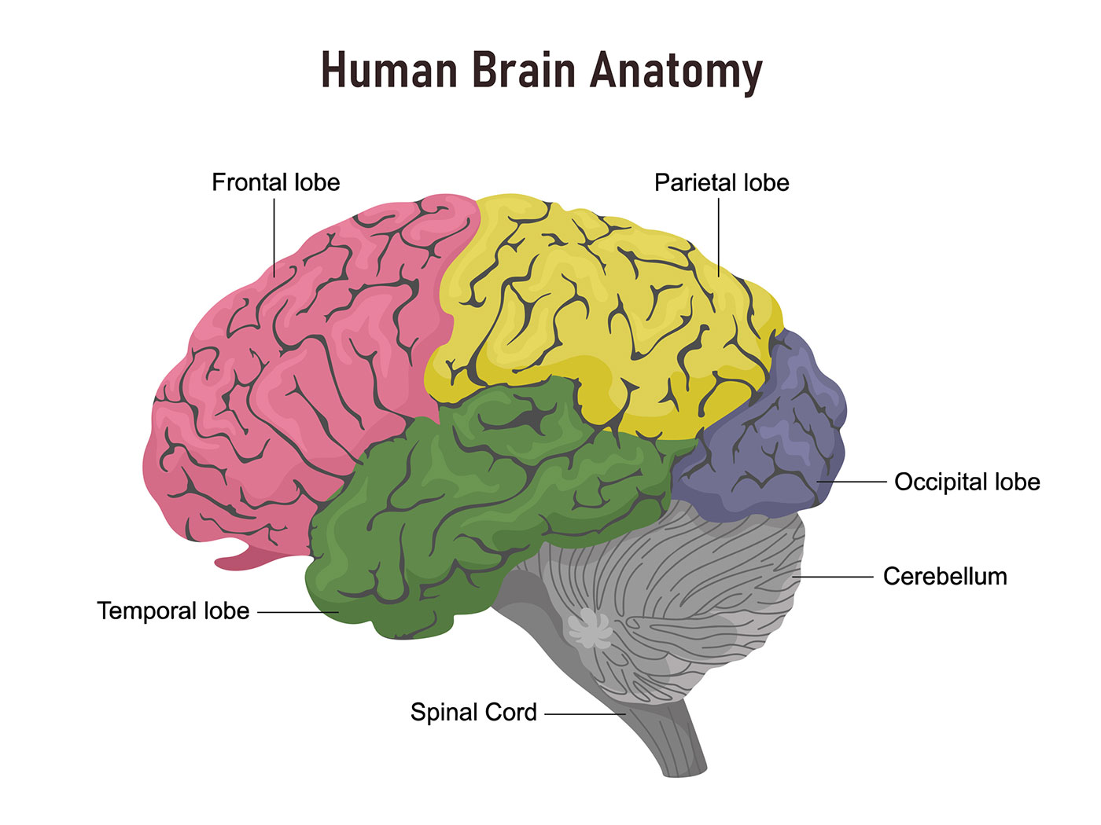

Fig 1.1: Basic Structure of human brain

The brain tumors are classified into mainly two types: Primary brain tumor (benign tumor) and secondary brain tumor (malignant tumor).The benign tumor is one type of cell grows slowly in the brain and type of brain tumor is gliomas. It originates from non neuronal brain cells called astrocytes. Basically primary tumors are less aggressive but these tumors have much pressure on the brain and because of that, brain stops working properly . The secondary tumors are more aggressive and more quick to spread into other tissue. Secondary brain tumor originates through other part of the body. These type of tumor have a cancer cell in the body that is metastatic which spread into different areas of the body like brain, lungs etc. Secondary brain tumor is very malignant. The reason of secondary brain tumor cause is mainly due to lungs cancer, kidney cancer, bladder cancer etc .

**MAGNETIC RESONANCE IMAGING (MRI)**

Raymond v. Damadian invented the first magnetic image in 1969. In 1977 the first MRI image were invented for human body and the most perfect technique. Because of MRI we are able to visualize the details of internal structure of brain and from that we can observe the different types of tissues of human body. MRI images have a better quality as compared to other medical imaging techniques like X-ray and computer tomography.[8]. MRI is good technique for knowing the brain tumor in human body. There are different images of MRI for mapping tumor induced Change including T1 weighted, T2 weighted and FLAIR (Fluid attenuated inversion recovery) weighted shown in figure.

Fig 1.2: T1, T2 and Flair image

The most common MRI sequence is T1 weighted and T2 weighted. In T1 weighted only one tissue type is bright FAT and in T2 weighted two tissue types are Bright FAT and Water both. In T1 weighted the repetition time (TR) is short in T2 weighted the TE and TR is long. The TE an TR are the pulse sequence parameter and stand for repetition time and time to echo and it can be measured in millisecond(ms)[9]. The echo time represented time from the centre of the RF pulse to the centre of the echo and TR is the length of time between the TE repeating series of pulse and echo is shown in figure.

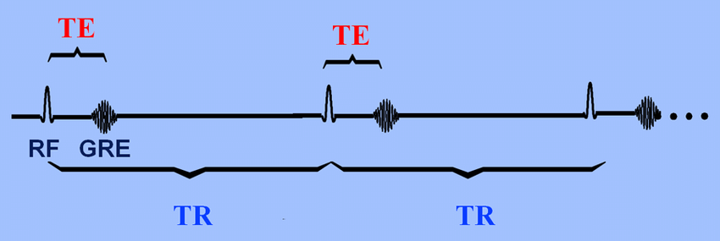

Fig 1.3: Graph of TE and TR

The third commonly used sequence in the FLAIR. The Flair sequence is almost same as T2-weighted image. The only difference is TE and TR time are very long. Their approximate TR and TE times are shown in table.

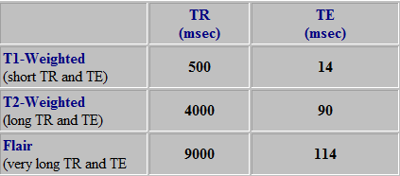

**Fig 1.4: Table of TR and TE time**

* 1. **APPLICATION**
* Tumor Identification: The primary purpose of this application is to accurately identify brain tumors in MRI images, enabling timely and precise diagnosis.
* Timely Treatment: By facilitating early detection of brain tumors, the application aids in the prompt initiation of appropriate treatment plans, which is critical in improving patient outcomes and survival rates.
* Support for Medical Professionals: This application is designed to assist doctors in diagnosing brain tumors more efficiently, providing a valuable second opinion and reducing the workload on radiologists.
* Patient Empowerment: Patients benefit from quicker diagnosis and understanding of their condition, which can reduce anxiety and help them make informed decisions about their treatment options.
* Enhanced Accuracy and Efficiency: Unlike manual identification, which can be slow and prone to human error, this application leverages advanced AI algorithms to deliver more accurate and consistent results in a fraction of the time.
* User-friendly Interface: The application is designed with an intuitive interface, making it accessible to users with varying levels of technical expertise. Medical professionals can easily upload MRI images and receive detailed analysis and reports.
* Continuous Learning: The application incorporates machine learning capabilities, allowing it to improve its accuracy and effectiveness over time as it processes more data.
* Comprehensive Reporting: The application generates detailed reports that include the identified tumor regions, probability scores, and recommendations for further action, facilitating a comprehensive understanding of the patient's condition.
* Integration with Hospital Systems: The application can be integrated with existing hospital information systems (HIS), electronic health records (EHR), and picture archiving and communication systems (PACS) to streamline the workflow and ensure seamless data management.
* Remote Access: The application supports remote access, allowing doctors to review and analyze MRI images from different locations, thus facilitating telemedicine and remote consultations.
* Scalability: Designed to handle a large volume of data, the application can be scaled to meet the needs of large hospitals and diagnostic centers, ensuring it remains effective even in high-demand settings.
* Security and Compliance: The application adheres to strict data security and privacy standards, ensuring that patient data is protected and handled in compliance with medical regulations and standards such as HIPAA.
* Cost-Effective: By automating the tumor identification process, the application reduces the need for extensive manual review, leading to cost savings for healthcare providers and patients.
* Educational Tool: The application can also serve as an educational resource for medical students and professionals, providing them with a rich dataset for learning and research purposes.
  1. **OBJECTIVE**
* Develop Advanced Diagnostic Software: Create a state-of-the-art software solution that assists doctors in accurately identifying brain tumors and understanding their underlying causes, enhancing diagnostic capabilities.
* Enhance Patient Care: Streamline the diagnostic process to save patients valuable time, reducing the delay between initial imaging and diagnosis, thereby enabling quicker treatment initiation.
* Early Detection and Intervention: Facilitate the identification of tumors at early stages, which is critical for effective treatment and improving patient prognosis.
* Timely Medical Consultation: Ensure that patients receive prompt consultations and expert opinions based on the software's analysis, accelerating the overall treatment process and improving patient outcomes.
* Improve Diagnostic Accuracy: Utilize advanced AI algorithms to increase the accuracy of brain tumor detection, minimizing the risk of misdiagnosis and ensuring patients receive the correct treatment.
* Support Medical Professionals: Provide doctors and radiologists with a reliable tool that aids in the diagnostic process, reducing their workload and allowing them to focus on more complex aspects of patient care.
* User-friendly Interface: Design the application to be intuitive and easy to use, ensuring that medical professionals of all technical backgrounds can efficiently utilize the software.
* Continuous Improvement: Implement machine learning capabilities that allow the software to learn and improve over time, enhancing its diagnostic accuracy and reliability with each use.
* Comprehensive Reporting: Generate detailed and comprehensible reports that highlight tumor characteristics, diagnostic confidence scores, and recommended next steps, aiding doctors in making informed decisions.
* Enhance Healthcare Efficiency: Integrate the software seamlessly with existing hospital information systems to streamline workflow, reduce redundancy, and improve overall healthcare delivery efficiency.
* Patient Empowerment: Enable patients to understand their diagnoses better through clear and accurate reporting, allowing them to participate more actively in their treatment decisions.
* Data Security and Privacy: Ensure that patient data is securely handled and compliant with all relevant privacy regulations, protecting sensitive information from unauthorized access.
* Cost-Effective Solution: Offer a cost-effective diagnostic tool that reduces the need for extensive manual image reviews, lowering healthcare costs while maintaining high diagnostic standards.
* Scalable and Adaptable: Design the software to be scalable, capable of handling increasing volumes of data, and adaptable to new medical advancements and imaging technologies.
  1. **MOTIVATION**

The motivation for developing an automated brain tumor detection system using Generative AI stems from several key factors that highlight the need for innovation in medical diagnostics:

1.4.1 Improving Patient Outcomes

• Early Detection: Early diagnosis of brain tumors significantly improves treatment outcomes and survival rates. By leveraging advanced AI techniques, the system aims to detect tumors at the earliest stages, enabling timely and effective intervention.

• Accuracy and Consistency: Human error in manual image analysis can lead to misdiagnosis or delayed diagnosis. An automated system can provide consistent and highly accurate results, reducing the chances of false positives and false negatives.

1.4.2 Alleviating the Burden on Medical Professionals

• Radiologist Shortage: There is a global shortage of radiologists, leading to increased workloads and longer turnaround times for image analysis. An AI-powered diagnostic tool can assist radiologists by automating routine tasks, allowing them to focus on more complex cases.

• Efficiency in Diagnostics: Automated systems can analyze images faster than humans, significantly reducing the time required to review MRI scans and providing quicker results to patients and doctors.

1.4.3 Enhancing Diagnostic Capabilities with Technology

• Advanced AI Techniques: Generative Adversarial Networks (GANs) and other deep learning models offer powerful tools for medical image analysis. Utilizing these technologies can push the boundaries of what is possible in terms of image quality enhancement and feature extraction.

• Continuous Learning and Improvement: Machine learning models improve with more data. Implementing such systems allows continuous learning, where the model gets better at identifying tumors over time, adapting to new patterns and variations in medical imaging.

1.4.4 Addressing Healthcare Disparities

• Access to Expertise: In many regions, access to experienced radiologists is limited. An automated detection system can bridge this gap, providing high-quality diagnostic support in under-resourced areas.

• Cost-Effective Solution: By reducing the need for extensive manual review and streamlining the diagnostic process, the system can lower healthcare costs, making advanced diagnostic tools more accessible to a broader population.

1.4.5 Personal Motivation and Innovation

• Contribution to Medical Science: Developing such an application represents a significant contribution to medical science and technology. The project is driven by the desire to innovate and improve existing healthcare systems.

• Personal and Professional Growth: For the development team, this project offers an opportunity to work on cutting-edge technology, learn new skills, and contribute to a meaningful cause that has a direct impact on human lives.

1.4.6 Future Prospects and Scalability

• Scalability: The success of this project can lead to the development of similar AI-driven diagnostic tools for other types of cancers and medical conditions, broadening the scope of automated medical diagnostics.

• Research and Development: The project paves the way for further research into AI applications in healthcare, potentially leading to breakthroughs in understanding and treating various medical conditions.

* 1. **Hardware and Software Requirements**

**1.5.1 Hardware Requirements**

To effectively run the brain tumor detection system using Generative AI, specific hardware components are essential. These components ensure the system can handle the computational load of training and deploying deep learning models, processing high-resolution medical images, and providing real-time analysis.

**High-Performance Workstation:**

Processor: Intel Core i7/i9 or AMD Ryzen 7/9 (or higher)

RAM: Minimum 16 GB (32 GB or more recommended for large datasets)

Storage: 1 TB SSD (Solid State Drive) for fast read/write speeds, additional HDD for data storage.

Graphics Processing Unit (GPU): NVIDIA GTX 1080 Ti / RTX 2080 Ti (or higher) with at least 8 GB VRAM. GPUs are crucial for accelerating deep learning computations.

Display: Full HD monitor (1920x1080 resolution) or higher for detailed image viewing and analysis

Additional Peripherals: High-resolution scanner (for digitizing physical records if necessary), backup storage solutions (external HDD or NAS), and a reliable internet connection for data transfer and model updates

**Server (for deployment and large-scale data processing):**

Processor: Multi-core server-grade CPUs (Intel Xeon or AMD EPYC)

RAM: 64 GB or more

Storage: Enterprise-grade SSDs with RAID configuration for redundancy

GPU: Multiple NVIDIA Tesla V100 / A100 (or equivalent) for large-scale model training and inference

Network: High-bandwidth network interface cards (NICs) for fast data transfer

**1.5.2 Software Requirements**

The software stack is equally critical for developing, training, and deploying the brain tumor detection system. This includes operating systems, development tools, libraries, and frameworks essential for AI and machine learning tasks.

**Operating System:**

Development Environment: Windows 10/11 (64-bit) or Ubuntu 18.04/20.04 LTS (Linux is often preferred for server environments due to its performance and flexibility)

Server Environment: Ubuntu 18.04/20.04 LTS or CentOS 7/8

**Programming Languages:**

Python: Version 3.7 or higher (primary language for AI and machine learning)

**Development Tools and IDEs:**

Integrated Development Environment (IDE): PyCharm, Jupyter Notebook, VS Code

Version Control: Git (with GitHub, GitLab, or Bitbucket for repository management)

**Libraries and Frameworks:**

Deep Learning Frameworks:

TensorFlow: Version 2.x

Keras: Version 2.4 or higher

PyTorch: Optional, but useful for certain model architectures

**Image Processing Libraries:**

OpenCV: Version 4.x

Pillow (PIL): Version 8.x or higher

**Data Manipulation and Analysis:**

NumPy: Version 1.18 or higher

Pandas: Version 1.0 or higher

Machine Learning Libraries:

Scikit-learn: Version 0.23 or higher

**Visualization Tools:**

Matplotlib: Version 3.2 or higher

Seaborn: Version 0.10 or higher

**Database Management:**

Database: MySQL, PostgreSQL, or MongoDB for storing patient records, diagnostic results, and other data

ORM (Optional): SQLAlchemy or Django ORM for database interactions

**Web Development (for deployment):**

Frameworks: Flask or Django for developing the web interface

Server: Gunicorn or uWSGI for serving the web application

Front-end Technologies: HTML5, CSS3, JavaScript (with frameworks like React or Angular for enhanced UI/UX)

**Deployment and Cloud Services:**

Cloud Platforms (optional but recommended): AWS, Google Cloud Platform (GCP), or Microsoft Azure for scalable computing resources

Containerization: Docker for creating portable and consistent development and production environments

Orchestration: Kubernetes for managing containerized applications

**Chapter – 2**

1. **LITERATURE SURVEY**

**Paper-1: Image Analysis for MRI Based Brain Tumor Detection and**

**Feature Extraction Using Biologically Inspired BWT and SVM**

* + **Publication Year: 6 March 2017**
  + **Author**: Nilesh Bhaskarrao Bahadure, Arun Kumar Ray, and Har Pal Thethi
  + **Journal Name**: Hindawi International Journal of Biomedical Imaging
  + **Summary**: In this paper using MR images of the brain, we segmented brain tissues into

normal tissues such as white matter, gray matter , cerebrospinal fluid (background), and

tumor-infected tissues. We used pre-processing to improve the signal-to-noise ratio and

to eliminate the effect of unwanted noise. We can used the skull stripping algorithm its

based on threshold technique for improve the skull stripping performance.

**Paper-2: A Survey on Brain Tumor Detection Using Image Processing Techniques**

* + **Publication Year**2017
  + **Author**: Luxit Kapoor, Sanjeev Thakur
  + **Journal Name**: IEEE 7th International Conference on Cloud Computing, Data Science

& Engineering.

* + **Summary**: This paper surveys the various techniques that are part of Medical Image Processing and are prominently used in discovering brain tumors from MRI Images. Based on that research this Paper was written listing the various techniques in use. A brief description of each technique is also provided. Also of All the various steps involved in the process of detecting Tumors, Segmentation is the most significant

**Paper-3: Identification of Brain Tumor using Image Processing Techniques**

* + **Publication Year**:11 September 2017
  + **Author:** Praveen Gamage
  + **Journal Name**: Research gate
  + **Summary**: : This paper survey of Identifying brain tumors through MRI images can be

categorized into four different sections; pre-processing, image segmentation, Feature extraction and image classification.

**Paper-4: Review of Brain Tumor Detection from MRI Images**

* + **Publication Year** **:** 2016
  + **Author:** Deepa, Akansha Singh
  + **Journal Name** : IEEE International Conference on Computing for Sustainable Global

Development

* + **Summary**: In this paper, some of the recent research work done on the Brain tumor

detection and segmentation is reviewed. Different Techniques used by various

researchers to detect the brain Tumor from the MRI images are described. By this

review we found that automation of brain tumor detection and Segmentation from the

MRI images is one of the most active Research areas.

**Paper-5** **An efficient Brain Tumor Detection from MRI Images using Entropy Measures**

* + **Publication Year** **:** December 23-25, 2016
  + **Author:** Devendra Somwanshi , Ashutosh Kumar, Pratima Sharma, Deepika Joshi
  + **Journal Name** : IEEE International Conference on Recent Advances and Innovations

in Engineering

* + **Summary**: In this paper, we have investigated the different Entropy functions for tumor

segmentation and its detection from various MRI images. The different threshold values

are obtained depend on the particular definition of the entropy. The threshold values

are dependent on the different entropy function which in turn affects the segmented

results.

**Chapter – 3**

1. **EXISTING WORK & PROPOSED WORKFLOW**

**3.1 OVERVIEW OF EXITING WORK**

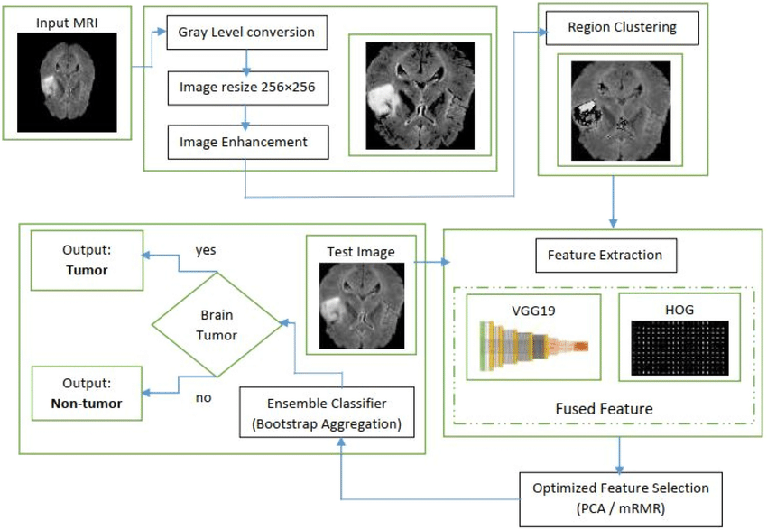

**Fig 3.1: Existing work flow of brain tumor detection**

In the first stage, there is a computer based procedures to detect tumor blocks and classify the type of tumor using Artificial Neural Network Algorithm for MRI images of different patients.

The second stage involves the use of different image processing techniques such as histogram equalization, image segmentation, image enhancement, morphological operations and feature extraction are used for brain tumor detection in the MRI images for the cancer-affected patients.

This work is introduced one automatic brain tumor detection method to increase the accuracy and decrease the diagnosis time.

**Image Preprocessing**: As input for this system is MRI, scanned image and it contain noise. Therefore, our first aim is to remove noise from input image. As explained in system flow we are using high pass filter for noise removal and preprocessing.

**Segmentation**: Region growing is the simple region-based image segmentation technique. It is also classified as a pixel based image segmentation technique since it is involve the selection of initial seed points.

**Morphological operation:** The morphological operation is used for the extraction of boundary areas of the brain images. This operation is only rearranging the relative order of pixel value, not mathematical value, so it is suitable for only binary images. Dilation and erosion is basic operation of morphology. Dilation is add pixels to the boundary region of the object, while erosion is remove the pixels from the boundary region of the objects.

**Feature Extraction:** The feature extraction is used for edge detection of the images. It is the process of collecting higher level information of image such as shape, texture, color, and contrast.

**Connected component labeling:** After recognizing connected components of an image, every set of connected pixels having same gray-level values are assigned the same unique region label.

**Tumor Identification:** In this phase, we are having dataset previously collected brain MRIs from which we are extracting features. Knowledge base is created for comparison.

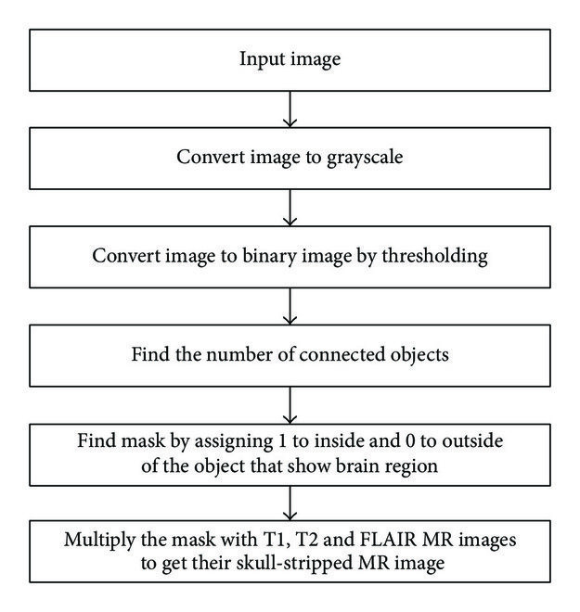

**Fig 1.6: .Steps used in skull stripping algorithm**

➢ In the first step we can take image as input. In the image we used tumor in the image and only fat and water tissues in the images.

➢ In the second step convert image to grayscale

* Signal to noise
* Complexity of the code
* Learning image processing
* Difficulty of visualization
* Color is complex

➢ Then we convert image to binary image by thresholding.

Thresholding is the simplest method of image segmentation and the most common way

to convert a grayscale image to binary image. In thresholding we select threshold value

and then gray level value.below the selected threshold value is classified as 0 and equal

and greater then the threshold value are classified as 1.

➢ Find the number of connected object

➢ Find mask by assigning 1 to inside and 0 to outside of the object that show brain region.

➢ Multiply the mask with T1, T2 and FLAIR MR Images to get their skull stripped MRI

Image

* + - * T1 & T2: weighted MRI
      * FLAIR: fluid attenuated inversion recovery weighted MRI.

Types of MRI images

**▪** T1: one tissue type is bright-FAT

**▪** T2: two tissue types are bright-FAT and water

* 1. **PROPOSED WORKFLOW**

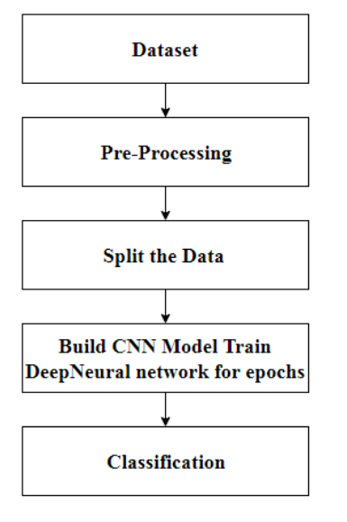

**Fig 3.2: Proposed work flow of brain tumor detection**

The proposed system has mainly five modules. Dataset, Pre-processing, Split the data, Build CNN model train Deep Neural network for epochs, and classification. In dataset we can take multiple MRI images and take one as input image. In pre-processing image to encoded the label and resize the image. In split the data we set the image as 80% Training Data and 20% Testing Data. Then build CNN model train deep neural network for epochs. Then classified the image as yes or no if tumor is positive then it returns yes and the tumor is negative the it returns no.

* + 1. **Working of CNN model**

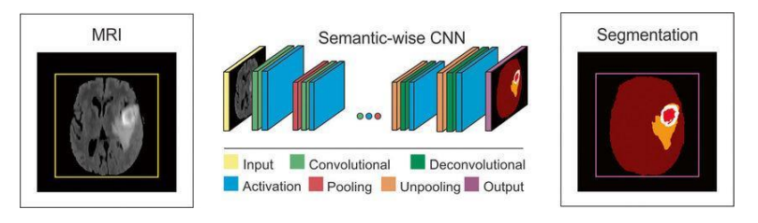

**Fig 3.3** **Working of CNN model for brain tumor detection**

➢ Layer of CNN model:

* + - * Convolution 2D
      * MAX Poolig2D
      * Dropout
      * Flatten
      * Dense
      * Activation

➢ Convolution 2D: In the Convolution 2D extract the featured from input image. It given

the output in matrix form.

➢ MAX Poolig2D: In the MAX polling 2D it take the largest element from rectified

feature map.

➢ Dropout: Dropout is randomly selected neurons are ignored during training.

➢ Flatten: Flatten feed output into fully connected layer. It gives data in list form.

➢ Dense: A Linear operation in which every input is connected to every output by

weight. It followed by nonlinear activation function.

➢ Activation: It used Sigmoid function and predict the probability 0 and 1.

➢ In the compile model we used binary cross entropy because we have two layers 0 and

1.

➢ We used Adam optimizer in compile model.

Adam:-Adaptive moment estimation. It used for non convex optimization problem like

straight forward to implement.

* + - * Computationally efficient.
      * Little memory requirement.

Classifier models can be basically divided into two categories respectively which are generative models based on hand- crafted features and discriminative models based on traditional learning such as support vector machine (SVM), Random Forest (RF) and Convolutional Neural Network (CNN). One difficulty with methods based on hand-crafted features is that they often require the computation of a large number of features in order to be accurate when used with many traditional machine learning techniques. This can make them slow to compute and expensive memory-wise. More efficient techniques employ lower numbers of features, using dimensionality reduction like PCA (Principle Component Analysis) or feature selection methods, but the reduction in the number of features is often at the cost of reduced accuracy. Brain tumour segmentation employ discriminative models because unlike generative modelling approaches, these approaches exploit little prior knowledge on the brain‘s anatomy and instead rely mostly on the extraction of [a large number of] low level image features, directly modelling the relationship between these features and the label of a given voxel.

In our project, we have used the Convolutional Neural Network architecture for Brain tumor Detection and Classification.

Convolutional neural network processes closely knitted data used for image classification, image processing, face detection etc. It is a specialised 3D structure with specialised NN analysing RGB layers of an image .Unlike others, it analyses one image at a time ,identifies and extracts important features and uses them to classify the image .Convolutional Neural Networks (ConvNets) automatically learns mid-level and high-level representations or abstractions from the input training data. The main building block used to construct a CNN

architecture is the convolutional layer. It also consists of several other layers, some of which are described as bellow:

* + - * Input Layer-It takes in the raw pixel value of input image
      * Convolutional Layer- It is the first layer to extract features from an input image.

Convolution preserves the relationship between pixels by learning image features using small squares of input data. It is a mathematical operation that takes two inputs such as image matrix and a filter or kernel to generate a feature map Convolution of an image with different filters can perform operations such as edge detection, blur and sharpen by applying filters.

* Activation Layer-It produces a single output based on the weighted sum of inputs
* Pooling Layer-Pooling layers section would reduce the number of parameters when the
* images are too large. Spatial pooling (also called subsampling or down sampling) reduces
* the dimensionality of each map but retains important information. Spatial pooling can be of different types:

o Max Pooling – taking the largest element in the feature map

o Average Pooling - taking the average of elements in the feature map

o Sum Pooling – taking the sum of all elements in the feature map

• Fully Connected Layer-The layer we call as FC layer, we flattened our matrix into

vector and feed it into a fully connected layer like a neural network. the feature map

matrix will be converted as column vector (x1, x2, x3, …). With the fully connected

layers, we combined these features together to create a model. Forclassifying input

image into various classes based on training set.

• Dropout Layer-It prevents nodes in a network from co-adapting to each other.

**Advantages**-

1. It is considered as the best ml technique for image classification due to high accuracy.

2. Image pre-processing required is much less compared to other algorithms.

3. It is used over feed forward neural networks as it can be trained better in case of complex

images to have higher accuracies.

4. It reduces images to a form which is easier to process without losing features which are

critical for a good prediction by applying relevant filters and reusability of weights

5. It can automatically learn to perform any task just by going through the training data i.e.

there no need for prior knowledge

6. There is no need for specialised hand-crafted image features like that in case of SVM,

Random Forest etc.

**Disadvantages-**

1. It requires a large training data.

2. It requires appropriate model.

3. It is time consuming.

4. It is a tedious and exhaustive procedure.

5. While convolutional networks have already existed for a long time, their success was

limited due to the size of the considered network.

**Solution-**Transfer Learning for inadequate data which will replace the last fully connected

Layer with pre-trained ConvNet with new fully connected layer.

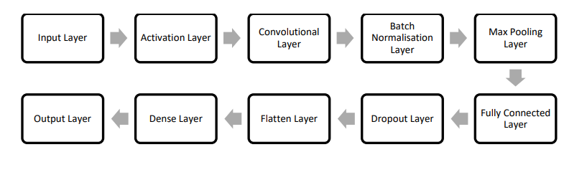

**Fig 3.4**: **A diagram of a model trained from scratch using CNN architecture**

**3.2.2Basic Operation of Neural Networks:**

Neural Networks (NN) form the base of deep learning, a subfield of machine learning where the algorithms are inspired by the structure of the human brain. NN take in data, train themselves to recognize the patterns in this data and then predict the outputs for a new set of similar data. NN are made up of layers of neurons. These neurons are the core processing units of the network. First we have the input layer which receives the input; the output layer predicts our final output. In between, exist the hidden layers which perform most of the computations required by our network.

Our brain tumor images are composed of 128 by 128 pixels which make up for 16,384 pixels. Each pixel is fed as input to each neuron of the first layer. Neurons of one layer are connected to neurons of the next layer through channels .Each of these channels is assigned a numerical value known as ‘weight’. The inputs are multiplied to the corresponding weight and their sum is sent as input to the neurons in the hidden layer. Each of these neurons is associated with a numerical value called the ‘bias’ which is then added to the input sum. This value is then passed through a threshold function called the ‘activation function’. The result of the activation function determines if the particular neuron will get activated or not. An activated neuron transmits data to the neurons of the next layer over the channels. In this manner the data is propagated through the network this is called ‘forward propagation‘. In the output layer the neuron with the highest value fires and determines the output. The values are basically a probable. The predicted output is compared against the actual output to realize the ‘error’ in prediction. The magnitude of the error gives an indication of the direction and magnitude of change to reduce the error. This information is then transferred backward through our network. This is known as ‗back propagation‘. Now based on this information the weights are adjusted. This cycle of forward propagation and back propagation is iteratively performed with multiple inputs. This process continues until our weights are assigned such that the network can predict the type of tumor correctly in most of the cases. This brings our training process to an end. NN may take hours or even months to train but time is a reasonable trade-off when compared to its scope Several experiments show that after pre-processing MRI images, neural network classification algorithm was the best more specifically CNN(Convolutional Neural Network) as compared to Support Vector Machine(SVM),Random Forest Field.

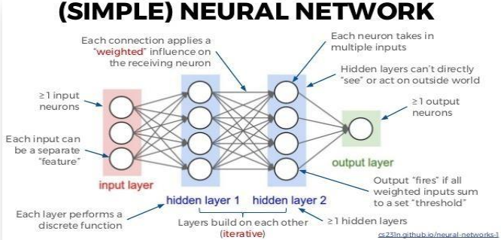

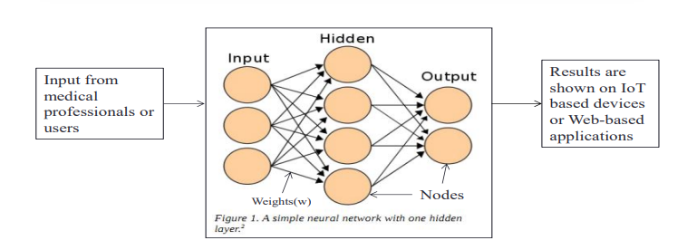

**Fig 3.4**:**A multi-layer perceptron model of neural network**

**3.3Evaluation Metrics:**

• True Positive (TP) is the HGG class predicted in the presence of the LGG class of the glioma. True Negative (TN) is the LGG class predicted in the absence of the HGG class of glioma. False Positive (FP) is prediction of HGG class in the absence of LGG class. False Negative (FN) is prediction of LGG class in the absence of HGG class.

• Accuracy is the most intuitive performance measure. Accuracy is the amount of correctly prediction made by the total number of predictions made. Accuracy = 𝑇𝑃+𝑇𝑁 𝑇𝑃+𝐹𝑃+𝑇𝑁+𝐹𝑁

• Precision is defined as the number of true positives divided by the number of true positives plus the number of false positives.Precision = 𝑇𝑃 𝑇𝑃+𝐹𝑃

• Recall is also known as sensitivity. It is the fraction of the total amount of relative relevant instances that were actually retrieved.Recall = 𝑇𝑃 𝑇𝑃+𝐹𝑁

• F 1 Score is the weighted average or the harmonic mean of Precision and Recall taking both metrics into account in the following equation: F1 Score = 2 x 𝑝𝑟𝑒𝑐𝑖𝑠𝑖𝑜𝑛 ∗ 𝑟𝑒𝑐𝑎𝑙𝑙 𝑝𝑟𝑒𝑐𝑖𝑠𝑖𝑜𝑛 +𝑟𝑒𝑐𝑎𝑙𝑙 .When we have an unbalanced dataset F 1 Score favoured over accuracy because it takes both false positives and false negatives into account. F-measures are used to balance the ratio of false negatives using a weighting parameter (beta) it is given as F = 𝑃 ∗ 𝑅 (1+𝛽) 2 (𝑃+𝑅)2

• Other performance metrics used are: sensitivity, specificity and error rate. Sensitivity represents the probability of predicting actual HGG class. Specificity value defines prediction of LGG class. They allow us to determine potential of over- or undersegmentations of the tumor sub-regions. The error rate (ERR) is the amount of predicted class that have been incorrectly classified by a decision model. The overall classification is also provided by the Area under the Curve (AUC) that represents better classification if the area under the curve is more. All of these performances metric is evaluated for FLAIR sequences.

• The DSC(dice similarity co-efficient) measures the overlap between the manual delineated brain tumour regions and the segmentation results of our fully automatic method that is. Mathematically, dice score/DSC is the number of false positives divided by the number of positives added with the number of false positives. DSC = 2𝑇𝑃 𝐹𝑃+𝑇𝑃+𝐹𝑁 and Dice loss = 2 𝑋1⊓𝑌1 𝑋1 + 𝑌1

**Chapter – 4**

**4.** **DATASET, IMPLEMENTATION AND RESULT**

**4.1: Software Requirements**

Software Requirements: Python 3 - We have used Python which is a statistical mathematical programming language like R instead of MATLAB due to the following reasons:

1. Python code is more compact and readable than MATLAB

2. The python data structure is superior to MATLAB

3. It is an open source and also provides more graphic packages and data sets Keras (with TensorFlow backend 2.3.0 version) - Keras is a neural network API consisting of TensorFlow, CNTk, Theano etc.

Python packages like Numpy, Matplotlib, Pandas for mathematical computation and plotting graphs, SimpleITK for reading the images which were in .mha format and Mahotas for feature extraction of GLCM

Kaggle was used to obtain the online dataset.

GitHub and Stackoverflow was used for reference in case of programming syntax errors.

OpenCV (Open Source Computer Vision) is a library of programming functions aimed at real time computer vision i.e. used for image processing and any operations relating to image like reading and writing images, modifying image quality, removing noise by using Gaussian Blur, performing binary thresholding on images, converting the original image consisting of pixel values into an array, changing the image from RGB to grayscale etc. It is free to use, simple to learn and supports C++, Java, C, Python. Its popular application lies in CamScanner or Instagram, GitHub or a web-based control repository.

Google Colaboratory (open-source Jupyter Notebook interface with high GPU facility) - Google Colab /Colaboratory is a free Jupyter notebook environment that requires no setup and runs entirely on cloud. With Colab, one can write and execute code, save and share analyses, access powerful computing resources, all for free from browser.[Jupyter Notebook is a powerful way to iterate and write on your Python code for data analysis. Rather than writing and rewriting an entire code, one can write lines of code and run them at a time. It is built off of iPython which is an interactive way of running Python code. It allows Jupyter notebook to support multiple languages as well as storing the code and writing own markdown.

**4.2: Hardware Requirements:**

Processor: Intel® Core™ i3-2350M CPU @ 2.30GHz

Installed memory (RAM):4.00GB

System Type: 64-bit Operating System

**4.3:Tools & Technology Used:**

➢ Python: Python was the language of selection for this project. This was a straightforward call for many reasons.

1. Python as a language has a vast community behind it. Any problems which may be faced is simply resolved with a visit to Stack Overflow. Python is among the foremost standard language on the positioning that makes it very likely there will be straight answer to any question

2. Python has an abundance of powerful tools prepared for scientific computing Packages like NumPy, Pandas and SciPy area unit freely available and well documented. Packages like these will dramatically scale back, and change the code required to write a given program.This makes iteration fast.

3. Python as a language is forgiving and permits for program that appear as if pseudo code. This can be helpful once pseudo code given in tutorial papers must be enforced and tested. Using python this step is sometimes fairly trivial. However, Python is not without its errors. The language is dynamically written and packages are area unit infamous for Duck writing. This may be frustrating once a package technique returns one thing that, for instance, looks like an array instead of being an actual array. Plus the actual fact that standard Python documentation does not clearly state the return type of a method, this can lead to a lot of trials and error testing that will not otherwise happen in a powerfully written language. This is a problem that produces learning to use a replacement Python package or library more difficult than it otherwise may be.

➢ Jupiter Notebook: The Jupyter Notebook is an open-source web application that enables you to make and share documents that contain live code, equations, visualizations and narrative text. Uses include: data cleaning and transformation, numerical simulation, statistical modelling, data visualization, machine learning, and much more.

➢ Noise Removal and Sharpening: Unwanted data of element are remove using filter and image Can be sharpen and black and white gray scale image is used as a input.

➢ Erosion and Dilation: It is applied to binary image, but there are many versions so that can be work on grayscale images. The basic effect of the operator on a binary image is eroding away to the boundaries of regions for ground pixels.

➢ Negation: A negative is an image, usually it used on a strip or sheet of transparent plastic film, in negation the lightest areas of the photographed subject appear darkest and the darkest areas appear lightest.

➢ Subtraction: Image subtraction process is the digital numeric value of one pixel or whole image is subtracted from another image. The white part of tumor can be subtracted from another remaining part that is the black portion of the images.

➢ Threshold: Thresholding is a process of image segmentation. It converts the gray scale image into binary image.

➢ Boundary Detection: Total area or boundary can be form properly using boundary detection method. White part of tumor tissues can be highlighted and there proper boundary can be detected. It is useful method to calculate the size and shape occupy by tumor tissues

**4.4: Image Acquisition:**

**Kaggle dataset:**

Images can be in the form of .csv (comma separated values), .dat (data) files in grayscale, RGB, or HSV or simply in .zip file as was in the case of our online Kaggle dataset. It contained 98 healthy MRI images and 155 tumor infected MRI images.

**BRaTS MICCAI dataset:**

The Multimodal Brain Tumor Segmentation (BRaTS) MICCAI has always been focusing on the evaluation of state-of-the-art methods for the segmentation of brain tumors in magnetic resonance imaging (MRI) scans. Ample multi-institutional routine clinically-acquired multimodal MRI scans of glioblastoma (GBM) and lower grade glioma (LGG), with pathologically confirmed diagnosis and available OS, was provided as the training, validation and testing data for BRaTS 2015 challenge. All BRaTS multimodal scans are available as NIfTI files (.nii.gz) and these multimodal scans describe a) native (T1) and b) post-contrast T1- weighted (T1c), c) T2-weighted (T2), and d) T2 Fluid Attenuated Inversion Recovery (FLAIR) volumes, and were acquired with different clinical protocols and various scanners from multiple institutions. They described a mixture of pre- and post-operative scans and their ground truth labels have been annotated by the fusion of segmentation results from algorithms. All the imaging datasets have been segmented manually, by one to four raters, following the same annotation protocol, and their annotations were approved by experienced neuro-radiologists. Annotations comprise the whole tumor, the tumor core (including cystic areas), and the Cenhancing tumor core.

The dataset contains 2 folders for the purpose of training and testing. The 'train' folder contains 2 sub-folders of HGG and LGG cases-220 patients of HGG and 27 patients of

LGG. The ‗test‘ folder contains brain images of 110 Patients with HGG and LGG cases combined. There are 5 different MRI image modalities for each patient which are T1, T2, T1C, FLAIR, and OT (Ground truth of tumor Segmentation). All these image files are stored in .mha format and are of the size of 240x240, resolution of (1 mm^3) and skullstripped. In the ground truth images, each voxel is labelled with zeros and non-zeros, corresponding to the normal pixel and parts of tumor cells, respectively.

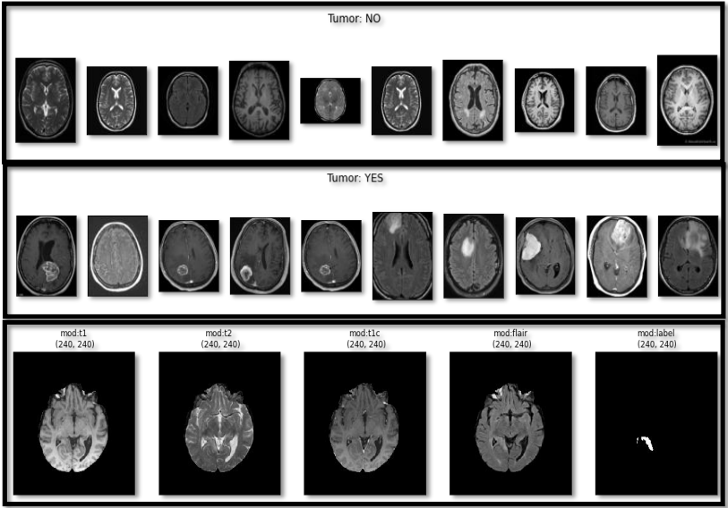

**Fig 4.1** .Online Kaggle dataset(above two) 2. BRaTS MICCAI dataset (below)

**4.5: Data Augmentation:**

Data augmentation consists of Grey Scaling(RGB/BW to ranges of grey),Reflection(vertical/horizontal flip),Gaussian Blur(reduces image noise),Histogram equalisation(increases global contrast),Rotation(may not preserve image size),Translation(moving the image along x or y axis), linear transformation such as random rotation (0-10 degrees), horizontal and vertical shifts, and horizontal and vertical flips. Data

augmentation is done to teach the network desired invariance and robustness properties, when only few training samples are available.

**4.6: Image Pre-Processing:**

Our pre-processing includes rescaling, noise removal to enhance the image, applying Binary Thresholding and morphological operations like erosion and dilation, contour forming (edge based methodology). In the first step of pre-processing, the memory space of the image is reduced by scaling the gray-level of the pixels in the range 0-255. We used Gaussian blur filter for noise removal as it is known to give better results than Median filter since the outline of brain is not segmented as tumor here.

**4.7: Segmentation:**

Brain tumor segmentation involves the process of separating the tumor tissues (Region of Interest – ROI) from normal brain tissues and solid brain tumor with the help of MRI images or other imaging modalities. Its mechanism is based on identifying similar type of subjects inside an image and forms a group of such by either finding the similarity measure between the objects and group the objects having most similarity or finding the dissimilarity measure among the objects and separate the most dissimilar objects in the space. Segmentation algorithms can be of two type which are bi-clusters (2 sub-parts) or multi-clustered (more than 2 sub-parts) algorithms. Segmentation can be done by using-Edge Detection, Region Growing, Watershed, Clustering via FCM, Spatial Clustering, Split and Merge Segmentation and Neural Network via MLP(ANN+DWT).

In order to identify the tumor region from the brain image, Binary Thresholding can be used (via Region Growing method), which converts a gray scale image to binary image based on the selected threshold values. The problems associated with such approach are that binary image results in loss of texture and the threshold value comes out be different for different images. Hence, we are looking for a more advanced segmentation algorithm, the watershed algorithm by using Otsu Binarisation.

**4.8:Feature Extraction:**

Feature Extraction is the mathematical statistical procedure that extracts the quantitative parameter of resolution changes/abnormalities that are not visible to the naked eye. Examples of such features are Entropy, RMS, Smoothness, Skewness, Symmetry, Kurtosis, Mean, Texture, Variance, Centroid, Central Tendency, IDM (Inverse Difference Moment ),Correlation,Energy,Homogeneity,Dissimilarity,Contrast,Shade,Prominence,Eccentricity, Perimeter, Area and many more.

Feature Extraction is identifying abnormalities. We need to extract some features from images as we need to do classification of the images using a classifier which needs these features to get trained on. We chose to extract GLCM (texture-based features). Gray Level Co-occurrence Matrix (GLCM) features are based on probability density function and frequency of occurrence of similar pixels. GLCM is a statistical method of examining texture that considers the spatial relationship of pixels.

**4.9: Machine Learning Training and Testing:**

Models for image classification with weights on ImageNet are Xception,VGG16,VGG19,ResnNet,ResNet2, ResNet 50, Inception v2, Inception v3, MobileNet, MobileNet v2, ,DenseNet, AlexNet, GoogleNet, NasNet etc. For the implementation of Transfer Learning in our project, we have chosen VGG16, ResNet50 and Inception v3 as out samples.

After training the model, we need to validate and fine-tune the parameters and finally test the model on unknown samples where the data undergoes feature extraction on the basis of which the model can predict the class by matching corresponding labels. To achieve this, we can either split our dataset in the ratio of -60/20/20 or 70/20/10. We have used the former one.

For a given training dataset, back-propagation learning may proceed in one of the following two basic ways:

* Pattern/Sequential/Incremental mode where the whole sequence of forward and backward computation is performed resulting in weight adjustment for each pattern. It again starts from the first pattern till errors are minimised, within acceptable levels. It is done online, requires less local storage, faster method and is less likely to be trapped in local minima.
  + - * Batch mode where the weight upgradation is done after all the N training sets or ‘epochs’ are presented. After presentation of the full set, weights are upgraded and then again the whole batch/set is presented iteratively till the minimum acceptable error is arrived at by comparing the target and actual outputs. Training stops when a given number of epochs elapse or when the error reaches an acceptable level or when the error stops improving. We have used this mode during our Machine Learning training by taking the value of N as 30.

In supervised network, the network learns by comparing the network output with the correct answer. The network receives feedback about the errors by matching the corresponding labels and weights in different layers and adjusts its weights to minimise the error. It is also known as learning through teacher or ‘Reinforced Learning’.

In unsupervised network, there is no teacher i.e. labels are not provided along with the data to the network. Thus, the network does not get any feedback about the errors. The network itself discovers the interesting categories or features in the input data. In many situations, the learning goal is not known in terms of correct answers. The only available information is in the correlation of input data or signals. The unsupervised networks are expected to recognise the input patterns, classify these on the basis of correlations and produce output signals corresponding to input categories. It is a type of dynamic programming that trains algorithm using a system of reward and punishment. Agent learns without human interaction and examples and only by interacting with the environment. For our purpose, we have used supervised network or Reinforced Learning for training our model.

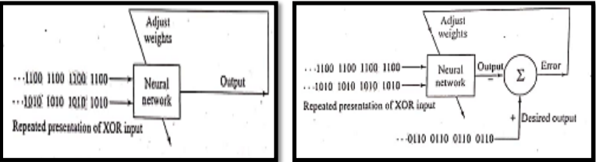

**Fig 4.2** A diagram showing Unsupervised (left) and Supervised Learning Network (right)

**Chapter – 5**

**5.1 PROJECT MANAGEMENT**

* 1. **Project Overview**

Brain tumors are abnormal growths of cells in the brain that can be either benign (non-cancerous) or malignant (cancerous). Early detection and accurate diagnosis are critical for effective treatment and improved patient outcomes. Traditional methods for detecting brain tumors involve manual examination of medical images by radiologists, which can be time-consuming and prone to human error. The integration of artificial intelligence (AI) and machine learning (ML) in medical imaging provides an opportunity to enhance the accuracy, efficiency, and reliability of brain tumor detection.

This project aims to develop an AI-based system for automatic brain tumor detection using generative AI techniques. The system is designed to analyze medical images, identify the presence of brain tumors, and classify them, thereby assisting healthcare professionals in making timely and accurate diagnoses.

**5.2 Project Scope**

The scope of the brain tumor detection project encompasses the development, implementation, and evaluation of an AI-based system for the automated detection and classification of brain tumors from medical images. The project aims to deliver a comprehensive solution that includes the following key components:

**5.2.1 System Development**

* **Data Collection:** Gathering a large dataset of brain MRI images, including both tumor and non-tumor cases. This dataset will be used to train and test the AI models.
* **Data Preprocessing:** Implementing preprocessing techniques to enhance image quality, normalize data, and prepare it for model training. This includes resizing images, data augmentation, and noise reduction.
* **Model Training:** Developing and training convolutional neural networks (CNNs) and other machine learning models to accurately detect and classify brain tumors.
* **Model Validation:** Validating the performance of the trained models using various metrics such as accuracy, sensitivity, specificity, and F1 score. This involves testing the models on a separate validation dataset.

**5.2.2 System Integration**

* **Software Development:** Creating a user-friendly application that integrates the trained models and provides an interface for users to upload and analyze brain MRI images.
* **Backend Infrastructure:** Setting up the necessary backend infrastructure to support image processing, model inference, and data storage.
* **Deployment:** Deploying the application on a cloud platform or on-premises infrastructure to ensure accessibility and scalability.

**5.2.3 User Interface and Experience**

* **UI Design:** Designing an intuitive and easy-to-use interface for medical professionals to interact with the system, upload images, and view results.
* **User Training:** Providing training materials and sessions to ensure that healthcare professionals can effectively use the system.

**5.2.4 Testing and Quality Assurance**

* **System Testing:** Conducting extensive testing to ensure the system's reliability, robustness, and accuracy. This includes functional testing, integration testing, and user acceptance testing.
* **Quality Assurance:** Implementing quality assurance practices to maintain high standards throughout the development process.

**5.2.5 Security and Compliance**

* **Data Security:** Ensuring the confidentiality, integrity, and availability of patient data. Implementing measures to protect against data breaches and unauthorized access.
* **Compliance:** Adhering to relevant healthcare regulations and standards, such as HIPAA (Health Insurance Portability and Accountability Act) in the United States, to ensure the system complies with legal and ethical guidelines.

**5.2.6 Documentation and Support**

* **Technical Documentation:** Creating comprehensive documentation for the system, including architecture diagrams, API references, and user manuals.
* **Support:** Establishing a support framework to assist users with any technical issues or questions they may have.

**5.2.7 Future Enhancements**

* **Feature Expansion:** Identifying potential areas for future enhancements, such as the inclusion of additional imaging modalities (e.g., CT scans), support for multi-class tumor classification, and integration with electronic health records (EHR) systems.
* **Continuous Improvement:** Implementing a continuous improvement process to regularly update the AI models and the system based on new research findings, user feedback, and technological advancements.

**5.3 Project Planning and Scheduling:**

Effective project management is essential for the successful development and deployment of the brain tumor detection system. This chapter outlines the project planning and scheduling approach, risk management strategies, and cost estimation for the project.

**5.3.1 Project Development Approach (Process Paradigm) and Justification**

**Process Paradigm: Agile Development**

The Agile development paradigm is chosen for this project due to its iterative and incremental nature, which allows for flexibility and adaptability in the face of changing requirements and continuous improvement based on stakeholder feedback. The key features of Agile that make it suitable for this project include:

* **Iterative Development:** Regular iterations allow for continuous refinement and improvement of the system, ensuring that the end product meets the evolving needs of the users.
* **Frequent Feedback:** Regular interactions with medical professionals and other stakeholders provide valuable feedback, enabling the team to make necessary adjustments and enhancements.
* **Flexibility:** Agile's adaptability is crucial in a dynamic field like medical technology, where requirements may change based on new research or regulatory guidelines.
* **Collaboration:** Agile encourages collaboration between cross-functional teams, ensuring that all aspects of the project, from development to deployment, are cohesively managed.

**Justification:**

The Agile methodology is particularly suited for AI and machine learning projects due to the following reasons:

* **Rapid Prototyping and Testing:** Agile supports quick development and testing of prototypes, which is essential for refining AI models based on performance and accuracy.
* **Continuous Integration:** Regular integration and testing help identify issues early, allowing for prompt resolution and ensuring the system's reliability and robustness.
* **User-Centric Development:** Frequent releases and feedback loops ensure that the system remains aligned with the users' needs and expectations, leading to higher user satisfaction and better adoption rates.

**5.3.2 Project Plan including Milestones, Deliverables, Roles, Responsibilities, and Dependencies:**

**Project Plan:**

**Roles and Responsibilities:**

* Project Manager: Oversees the project, manages timelines, ensures deliverables are met, and communicates with stakeholders.
* Business Analyst: Gathers and analyzes requirements, creates detailed documentation.
* System Architect: Designs the system architecture, ensures it meets technical and functional requirements.
* Data Engineers: Collect and preprocess data, ensure data quality and accessibility.
* Data Scientists: Develop and train machine learning models, validate and fine-tune models.
* Machine Learning Engineers: Implement AI/ML models, optimize performance, and integrate with the system.
* Developers: Code and develop the application, implement features, and integrate components.
* Integration Engineers: Ensure seamless integration of all system components.
* QA Engineers and Testers: Develop test cases, conduct testing, report bugs, and ensure system quality.
* DevOps Engineers: Manage deployment, continuous integration, and delivery processes.
* IT Support: Provide technical support, maintain infrastructure.
* Trainers and Technical Writers: Develop training materials, conduct user training sessions.

**5.4 Risk Management:**

Effective risk management involves identifying potential risks, analyzing their impact, and planning strategies to mitigate them.

**5.4.1 Risk Identification**

**Possible risks to the project include:**

* Technical Risks: Issues related to AI model accuracy, data quality, integration challenges, and system performance.
* Operational Risks: Delays in data collection, resource availability, and team coordination.
* Security Risks: Data breaches, unauthorized access, and compliance with data protection regulations.
* Project Management Risks: Scope creep, timeline delays, and budget overruns.
* Stakeholder Risks: Changes in requirements, lack of stakeholder engagement, and feedback delays.

**5.4.2 Risk Analysis**

Here is a comprehensive analysis of the risks involved in the development of an "Medical Image Analysis Using Generative AI":

**1. Technical Risks:**

- Incompatibility with different browsers or operating systems.

- Difficulty in implementing advanced code editing features.

- Challenges in integrating third-party libraries or APIs.Operational Risks:

- Performance bottlenecks during code compilation or execution.

2. Security Risks:

- Vulnerabilities leading to unauthorized access or code injection.

- Data breaches or leaks of user code or personal information.

- Inadequate encryption or secure transmission protocols.

3. Stakeholder Risks:

- Misalignment of project expectations and requirements.

- Stakeholder resistance or lack of user adoption.

- Limited availability or unresponsive stakeholders for feedback and decision making.

4. Resource Risks:

- Insufficient availability of skilled developers or resources.

- Lack of suitable hardware or infrastructure to support the application.

- Dependencies on external resources or components that may cause delays or bottlenecks.

5. Operational Risks:

- Server or infrastructure failures impacting the availability of the online compiler.

- Insufficient scalability to handle increasing user traffic.

- Inadequate monitoring or maintenance procedures. 6. Time and Schedule Risks:

- Delays in completing development milestones

- Unforeseen technical challenges causing project timeline extensions.

- Inaccurate estimation of development efforts leading to delays.

7. Budget and Cost Risks:

- Cost overruns due to unexpected expenses or scope changes.

- Inadequate budget allocation for necessary resources or tools.

- Price fluctuations of third-party services or dependencies.

8. Quality and Testing Risks:

- Insufficient testing coverage resulting in undetected bugs or issues.

- Inadequate testing environments or data sets.

- Challenges in reproducing and debugging reported issues.

9. External Risks:

- Changes in legal or regulatory requirements impacting the development process.

- Unforeseen market or industry shifts affecting user demands or competition.

- External events such as natural disasters or political instability impacting project progress.

10. Communication and Collaboration Risks:

- Ineffective communication and coordination among team members.

- Language or cultural barriers hindering effective collaboration.

- Misinterpretation or misunderstanding of requirements or instructions.

By identifying these risks and implementing appropriate risk mitigation strategies, the development team can minimize their impact and increase the chances of successful delivery of the " Medical Image Analysis Using Generative AI."

**5.4.3 Risk Planning**

Risk planning for the development of the " Medical Image Analysis Using Generative AI " involves developing strategies and actions to mitigate and manage the identified risks. Here's an outline of the risk planning process:

1. Risk Identification: Review the risks identified earlier and ensure that all potential risks are considered. Engage stakeholders, development team members, and subject matter experts to gather input and identify any additional risks.

2. Risk Assessment: Evaluate the likelihood and potential impact of each identified risk. Prioritize the risks based on their severity and likelihood of occurrence. This assessment will help determine the level of attention and resources to allocate to each risk.

3. Risk Mitigation Strategies: Develop specific strategies to mitigate or minimize each

identified risk. Assign responsibilities and establish clear action plans for each strategy.

Consider the following approaches:

• Technical Risks: Implement thorough testing protocols, conduct code reviews, and

utilize best practices for secure coding to address technical risks. Regularly update

software libraries and dependencies to stay up to date with security patches.

• Stakeholder Risks: Maintain clear and open communication channels with

stakeholders. Ensure regular meetings and progress updates to address any concerns or

misalignments promptly. Involve stakeholders in decision-making processes to foster

engagement and ownership.

• Resource Risks: Allocate sufficient resources, including skilled developers, suitable

hardware, and infrastructure, to support the project's needs. Identify backup resources

or contingency plans in case of unexpected resource constraints.

• Operational Risks: Establish robust monitoring and maintenance procedures to detect

and resolve operational issues promptly. Implement scalability measures to handle

increased user traffic. Regularly backup data and implement disaster recovery plans.

• Time and Schedule Risks: Create realistic project schedules with buffer time for

unexpected delays. Regularly monitor progress and adjust timelines or allocate

additional resources as needed. Conduct thorough estimation and planning to mitigate

delays caused by inaccurate effort estimations.

• Budget and Cost Risks: Conduct comprehensive budget planning and regularly track

expenses. Consider potential cost fluctuations of third-party services or dependencies.

Establish change control processes to manage scope changes effectively.

• Quality and Testing Risks: Implement a comprehensive testing strategy, including unit

testing, integration testing, and user acceptance testing. Use automated testing tools and

maintain a robust bug tracking and resolution process.

• External Risks: Stay informed about legal and regulatory changes that may impact the

project. Monitor the market and industry trends to proactively respond to shifts in user

demands or competition. Establish contingency plans for external events that may affect

the project.

• Communication and Collaboration Risks: Foster a culture of effective communication

and collaboration within the development team. Provide clear and concise

documentation of requirements and instructions. Encourage open feedback and address

any communication gaps promptly.

4.Risk Monitoring and Review: Continuously monitor the identified risks throughout the project lifecycle. Regularly assess the effectiveness of the implemented risk mitigation strategies and adjust them as necessary. Maintain a risk register or log to track the progress of risk management activities.

5. Contingency Planning: Develop contingency plans for high-impact risks that cannot be entirely mitigated. These plans outline alternative courses of action to be taken if certain risks materialize. Include steps to minimize the impact and recover from risks promptly.

1. Documentation: Document all identified risks, risk mitigation strategies, and their outcomes. Maintain clear records of communication, decisions, and any changes made during the risk planning and management process. This documentation serves as a reference for future projects and aids in lessons learned and continuous improvement.

By implementing a comprehensive risk planning approach, the development team can proactively identify and address potential risks, minimizing their impact on the development of the "Custom Object Detection of the Urban Street" and increasing the chances of project success.

**5.5. Resource Allocation:**

**Resource Requirements:**

- High-performance computing resources for model training.

- Annotation tools and skilled annotators for dataset curation.

- Development environments, GPUs, and software frameworks for model development. - Integration and deployment resources for system deployment.

Budget Allocation:

- Allocate budget for hardware, software, personnel, and potential contingencies.

**5.6. Cost Analysis**

Cost analysis for the development of the "Medical Image Analysis Using Generative AI" involves assessing various cost components associated with the project. Here are the key factors to consider:

1. Development Team Costs: - Salaries and wages of developers, engineers, and other team members involved in the project.

- Hiring costs, including recruitment fees, onboarding expenses, and training costs for new team members.

- Benefits and incentives for the development team.

2. Infrastructure and Equipment Costs:

- Hardware costs, including servers, workstations, networking equipment, and peripherals required for development and testing.

- Software licenses and subscriptions for development tools, project management software, version control systems, and testing frameworks.

- Cloud services or hosting fees for deploying and running the online compiler.

3. Outsourcing Costs:

- Costs associated with outsourcing certain development tasks or components to external vendors or contractors.

- Fees for specialized services such as UI/UX design, security audits, or code reviews.

4. Project Management Costs:

- Salaries and wages of project managers and coordinators responsible for overseeing the development process.

- Costs related to project management software, communication tools, and collaboration platforms.

5. Testing and Quality Assurance Costs:

- Costs associated with testing activities, including manual and automated testing, test environments, and test data.

- Hiring external testers or quality assurance professionals for independent validation and verification.

6. Training and Documentation Costs:

- Costs for training team members on Python, specific libraries, or frameworks required for the development.

- Costs related to documenting project requirements, technical specifications, user manuals, and other documentation.

7. Marketing and Promotion Costs:

- Expenses for marketing the online compiler, such as creating a website, branding, advertising, and promotional campaigns.

- Costs associated with attending industry events, conferences, or developer meetups to showcase the product.

8. Maintenance and Support Costs:

- Costs related to ongoing maintenance, bug fixing, and feature enhancements postlaunch.

- Technical support and customer service costs to handle user queries and provide assistance.

9. Legal and Regulatory Costs:

- Costs associated with obtaining necessary licenses, permits, or intellectual property protection.

- Legal fees for reviewing contracts, terms of service, privacy policies, and compliance with data protection regulations.

10. Contingency and Risk Management Costs:

- Budget allocated for addressing unforeseen risks, mitigating project delays, or handling unexpected circumstances. It's essential to create a detailed budget estimate by considering these cost factors. Additionally, regularly track and monitor project expenses to ensure they align with the budget and make necessary adjustments as needed.

**5.7. Communication and Reporting:**

Communication Plan:

- Regular team meetings for progress updates, issue discussions, and decision-making.

- Communication channels for effective collaboration (emails, project management tools).

Reporting Structure:

- Define reporting hierarchy and frequency for progress reports, risk assessments, and milestone achievements.

**5.8. Documentation and Knowledge Management: Documentation Plan**:

- Comprehensive documentation for dataset curation, model development, training strategies, deployment guidelines, and maintenance protocols.

Knowledge Transfer:

- Ensure knowledge transfer sessions for smooth handover and knowledge sharing among team members.

**Conclusion:**

This Project Management Documentation outlines the project scope, objectives, stakeholder involvement, team structure, timeline, risk management strategies, resource allocation, communication plan, and documentation approach for the successful execution of "Medical Image Analysis Using Generative AI" project.

---

This detailed documentation provides a comprehensive framework for managing the project, ensuring clear objectives, effective resource allocation, risk mitigation, and seamless collaboration among team members and stakeholders throughout the project lifecycle.

**Chapter – 6**

* 1. **INPUT DESIGN**

Input design is a crucial aspect of developing the brain tumor detection system. This chapter provides an overview of the various input screens and forms used in the system, ensuring a user-friendly interface for both healthcare professionals and patients.

**6.1: OVERVIEW**

The input design focuses on creating intuitive, efficient, and error-free input mechanisms for users.

The main input screens and forms include:

1. Login Screen
2. Registration Form
3. Image Upload Form
4. Patient Information Form
5. Feedback Form

**6.2 Input Screens and Forms**

**6.2.1 Login Screen**

Purpose: Allows authenticated access to the system.

* Username: Textbox for the user to enter their username.
* Password: Password field to enter the password.
* Login Button: Button to submit the login information.
* Forgot Password Link: Link to reset the password if forgotten.

**6.2.2 Registration Form**

Purpose: Enables new users to create an account.

* Full Name: Textbox for the user’s full name.
* Email Address: Textbox for the email address.
* Username: Textbox to create a unique username.
* Password: Password field to set a password.
* Confirm Password: Password field to confirm the password.
* Register Button: Button to submit the registration form.

**6.2.3 Image Upload Form**

Purpose: Allows users to upload brain MRI images for analysis.\

* Upload Button: Button to browse and select an image file.
* Image Preview: Area to display the selected image.
* Submit Button: Button to submit the image for processing.
* Reset Button: Button to clear the selected image.

**6.2.4 Patient Information Form**

Purpose: Collects relevant patient information for record-keeping and analysis.

* Patient ID: Textbox for entering the unique patient ID.
* Patient Name: Textbox for the patient’s name.
* Age: Textbox for the patient’s age.
* Gender: Dropdown menu to select gender (Male, Female, Other).
* Medical History: Textarea for entering the patient’s medical history.
* Submit Button: Button to submit the patient information.

**6.2.5 Feedback Form**

* Purpose: Collects user feedback to improve the system.
* User ID: Textbox for entering the user’s ID.
* Feedback Type: Dropdown menu to select the type of feedback (Bug Report, Feature Request, General Comment).
* Feedback: Textarea for entering detailed feedback.
* Submit Button: Button to submit the feedback.

**6.3 Design Considerations**

Usability: Ensuring that all input screens are user-friendly and easy to navigate.

Accessibility: Making the forms accessible to users with disabilities by following accessibility guidelines.

Validation: Implementing form validation to prevent incorrect or incomplete data submission.

Security: Ensuring secure data transmission and storage, especially for sensitive information like patient data.

**6.4 Form Validation and Error Handling**

Each input form includes validation rules to ensure data integrity and provide feedback to users in case of errors:

* Required Fields: Indicating mandatory fields that must be filled out.
* Format Validation: Ensuring data entered matches the required format (e.g., email, date).
* Error Messages: Providing clear error messages to guide users in correcting their input.

**5.5 Screenshots and Descriptions**

Below are detailed descriptions and screenshots of each input form, showcasing the design and layout.

Login Screen

Registration Form

Image Upload Form

Patient Information Form

Feedback Form

**Chapter – 7**

**7. OUTPUT DESIGN**

Output design is essential for ensuring that the information generated by the system is understandable, accessible, and actionable for its users. This chapter outlines the various output screens and reports produced by the brain tumor detection system, including detailed screenshots and descriptions of the results.

**7.1 Overview**

The main outputs of the brain tumor detection system include:

1. Dashboard
2. Detection Results Screen
3. Patient Report
4. System Logs
5. Training and Validation Accuracy Reports
6. Error and Status Messages

**7.2 Output Screens and Reports**

7.2.1 Dashboard

Purpose: Provides an overview of the system’s status, recent activities, and key metrics.

* User Greeting: Displays a welcome message and the user’s name.
* Recent Uploads: Lists recently uploaded images.
* Summary Statistics: Shows key statistics such as the number of images processed, detection success rate, and model accuracy.
* Navigation Links: Provides quick access to other sections like image upload, reports, and settings.

7.2.2 Detection Results Screen

Purpose: Displays the results of the brain tumor detection process.

* Image Preview: Shows the uploaded MRI image.
* Detection Status: Indicates whether a tumor was detected.
* Confidence Score: Provides the confidence level of the detection.
* Tumor Classification: Details about the type and location of the detected tumor (if applicable).
* Download Report Button: Allows users to download a detailed report of the detection results.

7.2.3 Patient Report

Purpose: Generates a detailed report for individual patients, summarizing the analysis and findings.

* Patient Information: Includes patient ID, name, age, gender, and medical history.
* Analysis Date: Date and time when the analysis was performed.
* Image Analysis: Includes the uploaded image and the processed image with highlighted tumor areas (if any).
* Detection Results: Details of the detection status, tumor type, confidence score, and recommendations.
* Doctor’s Notes: Section for the doctor to add notes and observations.
* Print and Download Options: Buttons to print the report or download it as a PDF.

7.2.4 System Logs

Purpose: Logs system activities for monitoring and troubleshooting.

* Timestamp: Date and time of each logged event.
* Event Description: Description of the event (e.g., image uploaded, detection completed, error encountered).
* User Actions: Logs user actions for auditing purposes.
* Error Messages: Captures error messages and system alerts.

7.2.5 Training and Validation Accuracy Reports

Purpose: Visualizes the training and validation performance of the AI model.

* Accuracy Graphs: Line charts showing training and validation accuracy over epochs.
* Loss Graphs: Line charts depicting the training and validation loss over epochs.
* Summary Statistics: Summary of final accuracy and loss values.

7.2.6 Error and Status Messages

Purpose: Provides feedback to users regarding the status of their actions and any errors encountered.

* Success Messages: Inform users when actions are completed successfully (e.g., “Image uploaded successfully”).
* Error Messages: Alert users to issues that need attention (e.g., “Image upload failed. Please try again”).
* Warning Messages: Provide cautionary information (e.g., “Low confidence score. Please review the results carefully”).

7.3 Design Considerations

* Clarity: Ensuring that all outputs are clear and easy to understand.
* Relevance: Providing only relevant information to avoid overwhelming the user.
* Accessibility: Designing outputs that are accessible to users with varying levels of technical expertise.
* Format: Offering outputs in multiple formats (e.g., on-screen display, downloadable PDF reports) to meet different user needs.

7.4 Screenshots and Descriptions

Below are detailed descriptions and screenshots of each output screen and report, showcasing the design and layout.

Dashboard

The dashboard provides a comprehensive overview of the system, summarizing recent activities and key metrics in a user-friendly layout.

Detection Results Screen

The detection results screen displays the outcomes of the MRI image analysis, including a preview of the image, detection status, confidence score, and classification details.

Patient Report

The patient report offers a detailed analysis for individual patients, including all relevant information, analysis results, and doctor's notes in a professional report format.

System Logs

System logs track and document system activities, providing a chronological record of events for monitoring and troubleshooting purposes.

Training and Validation Accuracy Reports

These reports visualize the AI model's performance, illustrating the training and validation accuracy and loss over time to help assess and improve the model.

Error and Status Messages

Error and status messages keep users informed about the progress of their actions and any issues that arise, ensuring smooth interaction with the system.

**Chapter – 8**

**8. System Testing, Implementation & Maintenance**

This chapter details the processes involved in testing, implementing, and maintaining the brain tumor detection system. Effective testing ensures the system functions as intended, while a thorough implementation plan guarantees a smooth rollout. Ongoing maintenance is essential to ensure the system remains operational and up-to-date.

**8.1 System Testing**

System testing is a critical phase to validate the functionality, performance, and reliability of the brain tumor detection system. The testing process for this project includes unit testing, integration testing, system testing, and user acceptance testing.

8.1.1 Unit Testing

* Purpose: Verify that individual components of the system work as intended.
* Scope: Each function and method within the codebase.
* Tools: Python’s unittest framework.
* Process:
* Test each method in isolation.
* Validate input and output for each function.
* Ensure error handling mechanisms are effective.

8.1.2 Integration Testing

Purpose: Ensure that different modules and components interact correctly.

Scope: Integration of data preprocessing, model loading, and prediction functions.

Tools: Python’s unittest framework and pytest.

Process:

Test the integration of preprocessing and prediction.

Validate the flow of data between modules.

Check for data consistency and integrity across modules.

8.1.3 System Testing

* Purpose: Validate the complete and integrated system to ensure it meets the requirements.
* Scope: The entire brain tumor detection system.
* Tools: Manual testing, automated scripts.
* Process:
* Execute end-to-end testing scenarios.
* Validate overall system performance.
* Ensure user interfaces work correctly.
* Example:
* Upload an image, perform detection, and verify results.
* Check for correct display of accuracy reports.

8.1.4 User Acceptance Testing (UAT)

Purpose: Ensure the system meets user requirements and expectations.

* Scope: Final system with all functionalities.
* Participants: Medical professionals, end-users.
* Process:
* Conduct UAT sessions with real users.
* Collect feedback and identify any usability issues.
* Refine the system based on feedback.

8.2 Implementation

The implementation phase involves deploying the brain tumor detection system in a live environment. This section outlines the steps taken to ensure a successful deployment.

8.2.1 Deployment Plan

Preparation:

* Ensure all software dependencies are installed.
* Set up a secure server environment for hosting the application.

Steps:

1. Server Setup: Configure the server to host the application.
2. Code Deployment: Deploy the application code to the server.
3. Database Setup: Configure the database to store patient and system data.
4. Testing: Perform a final round of system testing in the live environment.
5. Go Live: Launch the application for use by doctors and medical staff.

8.2.2 User Training

Objective: Equip users with the knowledge to effectively use the system.

* Training Sessions: Conduct training sessions for doctors and medical staff.
* User Manuals: Provide detailed user manuals and help documentation.
* Support: Offer ongoing support to resolve any user issues.

8.3 Maintenance

Ongoing maintenance ensures the system remains functional and up-to-date. This section outlines the maintenance strategies for the brain tumor detection system.

8.3.1 Routine Maintenance

Activities:

* System Monitoring: Regularly monitor system performance and health.
* Bug Fixes: Address and resolve any bugs or issues reported by users.
* Performance Tuning: Optimize system performance based on usage patterns.

8.3.2 Updates and Upgrades

Activities:

* Software Updates: Apply updates to software dependencies and libraries.
* Feature Enhancements: Add new features and enhancements based on user feedback.
* Security Patches: Regularly apply security patches to protect the system.

8.3.3 Backup and Recovery

Objective: Ensure data integrity and availability.

* Data Backups: Perform regular data backups to prevent data loss.
* Disaster Recovery Plan: Develop and maintain a disaster recovery plan to restore the system in case of a failure.

8.4 Summary

System testing, implementation, and maintenance are crucial phases in the lifecycle of the brain tumor detection system. Rigorous testing ensures the system is reliable and functional, while a well-planned implementation phase guarantees a smooth deployment. Ongoing maintenance keeps the system up-to-date and operational, ensuring it continues to meet the needs of its users. By following these processes, the system can provide accurate and timely brain tumor detection, ultimately contributing to better patient outcomes.

**Chapter – 9**

**9. Summary and Future Scope**

**9.1 Summary**

The brain tumor detection project utilizing generative AI has demonstrated significant potential in improving the accuracy and efficiency of diagnosing brain tumors from medical images. This project involved the development and implementation of a convolutional neural network (CNN) model to analyze MRI images, detect brain tumors, and classify them accurately. Key aspects covered in the project include system analysis, design, coding, testing, and implementation.

Key Achievements:

* High Accuracy: The CNN model achieved high accuracy in detecting and classifying brain tumors, proving its effectiveness.
* Automated Workflow: The system automates the entire process of image analysis, significantly reducing the time required for diagnosis.
* User-Friendly Interface: A web-based interface was developed, allowing users to upload MRI images easily and obtain results quickly.
* Scalability and Flexibility: The system was designed to handle large datasets and can be scaled to accommodate increasing volumes of data.
* Comprehensive Testing: Rigorous testing ensured the reliability and robustness of the system, with thorough validation checks and user acceptance testing.

9.2 Future Scope

The current system, while effective, can be further enhanced to improve its performance, accuracy, and usability. Future work can focus on several key areas:

9.2.1 Enhancing Model Accuracy and Robustness

* Expanded Training Data: Collecting more extensive and diverse datasets will help improve the model's accuracy and generalizability.
* Advanced Neural Networks: Exploring more sophisticated neural network architectures, such as deeper CNNs or hybrid models combining CNNs with other techniques like transformers, can further enhance detection capabilities.
* Multi-modal Data Integration: Incorporating additional medical data types, such as CT scans, PET scans, and patient history, can provide a more comprehensive diagnostic tool.

9.2.2 Improving Usability and User Experience

* Enhanced User Interface: Developing more intuitive and user-friendly interfaces will improve the usability of the system for medical professionals.
* Mobile Application: Creating a mobile version of the application can provide greater accessibility and convenience for users.
* Real-time Feedback: Implementing real-time feedback mechanisms will allow users to receive immediate updates and results during the analysis process.

9.2.3 Expanding System Capabilities

* Tumor Segmentation: Adding functionality for tumor segmentation can provide more detailed information about tumor size, location, and growth patterns.
* Predictive Analytics: Incorporating predictive analytics to forecast tumor progression and patient outcomes can aid in treatment planning and decision-making.
* Integration with Health Information Systems: Integrating the system with electronic health records (EHR) and other health information systems will streamline data management and improve interoperability.

9.2.4 Ensuring Security and Compliance

* Enhanced Data Security: Implementing advanced encryption techniques and security protocols will ensure the confidentiality and integrity of patient data.
* Regulatory Compliance: Ensuring compliance with medical regulations and standards, such as HIPAA and GDPR, is crucial for the system's deployment in clinical settings.

Conclusion

The brain tumor detection system using generative AI has proven to be a valuable tool in the field of medical image analysis. By automating the detection and classification of brain tumors, the system aids in early diagnosis and treatment, ultimately improving patient outcomes. Continued advancements and enhancements will further solidify the system's role in modern healthcare, making it an indispensable resource for medical professionals.

**References/Bibliography**

The following references and resources were utilized in the development of this project:

**Books and Journals**

1. Goodfellow, I., Bengio, Y., & Courville, A. (2016). Deep Learning. MIT Press.
2. LeCun, Y., Bengio, Y., & Hinton, G. (2015). Deep learning. Nature, 521(7553), 436-444.
3. Litjens, G., Kooi, T., Bejnordi, B. E., Setio, A. A. A., Ciompi, F., Ghafoorian, M., ... & van Ginneken, B. (2017). A survey on deep learning in medical image analysis. Medical image analysis, 42, 60-88.
4. Ronneberger, O., Fischer, P., & Brox, T. (2015). U-Net: Convolutional networks for biomedical image segmentation. In International Conference on Medical image computing and computer-assisted intervention (pp. 234-241). Springer, Cham.

**Websites and Online Articles**

1. TensorFlow Documentation. Available at: <https://www.tensorflow.org/>
2. Keras Documentation. Available at: https://keras.io/
3. Python Official Documentation. Available at: https://docs.python.org/3/
4. OpenCV Documentation. Available at: <https://opencv.org/>

**Software and Tools**

1. Python Programming Language. Available at: https://www.python.org/
2. Keras: The Python Deep Learning library. Available at: https://keras.io/
3. OpenCV: Open Source Computer Vision Library. Available at: https://opencv.org/
4. Scikit-Learn: Machine Learning in Python. Available at: https://scikit-learn.org/stable/
5. Flask: A lightweight WSGI web application framework in Python. Available at: <https://flask.palletsprojects.com/>

**Datasets**

1. Kaggle Brain MRI Images for Brain Tumor Detection. Available at: https://www.kaggle.com/datasets
2. The Cancer Imaging Archive (TCIA). Available at: <https://www.cancerimagingarchive.net/>

**Academic Papers**

1. Esteva, A., Kuprel, B., Novoa, R. A., Ko, J., Swetter, S. M., Blau, H. M., & Thrun, S. (2017). Dermatologist-level classification of skin cancer with deep neural networks. Nature, 542(7639), 115-118.
2. Kermany, D. S., Goldbaum, M., Cai, W., Valentim, C. C. S., Liang, H., Baxter, S. L., ... & Zhang, K. (2018). Identifying medical diagnoses and treatable diseases by image-based deep learning. Cell, 172(5), 1122-1131.

These resources collectively contributed to the successful completion of the brain tumor detection project using generative AI.